Guidelines for reviewers

Registered Reports are a form of empirical article offered at Psychology of Sport and Exercise in which the methods and proposed analyses are pre-registered and reviewed prior to research being conducted. High quality protocols are then provisionally accepted for publication before data collection commences. This format is designed to minimize publication bias and research bias in hypothesis-driven research, while also allowing the flexibility to conduct exploratory (unregistered) analyses and report serendipitous findings.

The review process for Registered Reports is divided into two stages. At Stage 1, reviewers assess study proposals before data are collected. At Stage 2, reviewers consider the full study, including results and interpretation.

Stage 1 manuscripts will include only an Introduction, Methods (including proposed analyses), and Pilot Data (where applicable). In considering papers at Stage 1, reviewers will be asked to assess:

- The importance of the research question(s).
- The logic, rationale, and plausibility of the proposed hypotheses.
- The soundness and feasibility of the methodology and analysis pipeline (including statistical power analysis where appropriate).
- Whether the clarity and degree of methodological detail is sufficient to exactly replicate the proposed experimental procedures and analysis pipeline.
- Whether the authors have pre-specified sufficient outcome-neutral tests for ensuring that the results obtained are able to test the stated hypotheses, including positive controls and quality checks.

Following Stage 1 peer review, manuscripts will be accepted, offered the opportunity to revise, or rejected outright. Manuscripts that pass peer review will be issued an in principle acceptance (IPA), indicating that the article will be published pending successful completion of the study according to the pre-registered methods and analytic procedures, as well as a defensible and evidence-based interpretation of the results.

Following completion of the study, authors will complete the manuscript, including Results and Discussion sections. These Stage 2 manuscripts will more closely resemble a regular article format. The manuscript will then be returned to the reviewers, who will be asked to appraise:

- Whether the data are able to test the authors’ proposed hypotheses by satisfying the approved outcome-neutral conditions (such as quality checks, positive controls)
- Whether the Introduction, rationale and stated hypotheses are the same as the approved Stage 1 submission (required)
- Whether the authors adhered precisely to the registered experimental procedures
- Whether any unregistered post hoc analyses added by the authors are justified, methodologically sound, and informative
- Whether the authors’ conclusions are justified given the data

Reviewers at Stage 2 may suggest that authors report additional post hoc tests on their data; however authors are not obliged to do so unless such tests are necessary to satisfy one or more of the Stage 2 review criteria. Please note that editorial decisions will not be based on the perceived importance, novelty, or conclusiveness of the results.
Guidelines for authors

Registered Reports are a form of empirical article in which the methods and proposed analyses are pre-registered and reviewed prior to research being conducted. This format is designed to minimise bias in deductive science, while also allowing complete flexibility to conduct exploratory (unregistered) analyses and report serendipitous findings.

The cornerstone of the Registered Reports format is that a significant part of the manuscript will be assessed prior to data collection, with the highest quality submissions accepted in advance. Initial submissions will include a description of the key research question and background literature, hypotheses, experimental procedures, analysis pipeline, a statistical power analysis (or Bayesian equivalent), and pilot data (where applicable).

Initial submissions will be triaged by an editorial team for high scientific significance. Those that pass triage will then be sent for in-depth peer review (Stage 1). Following review, the article will then be either rejected or accepted in principle for publication. Following in principle acceptance (IPA), the authors will then proceed to conduct the study, adhering exactly to the peer-reviewed procedures. When the study is complete the authors will submit their finalised manuscript for re-review (Stage 2) and in will upload their raw data, digital study materials, and laboratory log to a publicly accessible file-sharing service. Pending quality checks and a sensible interpretation of the findings, the manuscript will be published regardless of the results.

The review process for Registered Reports

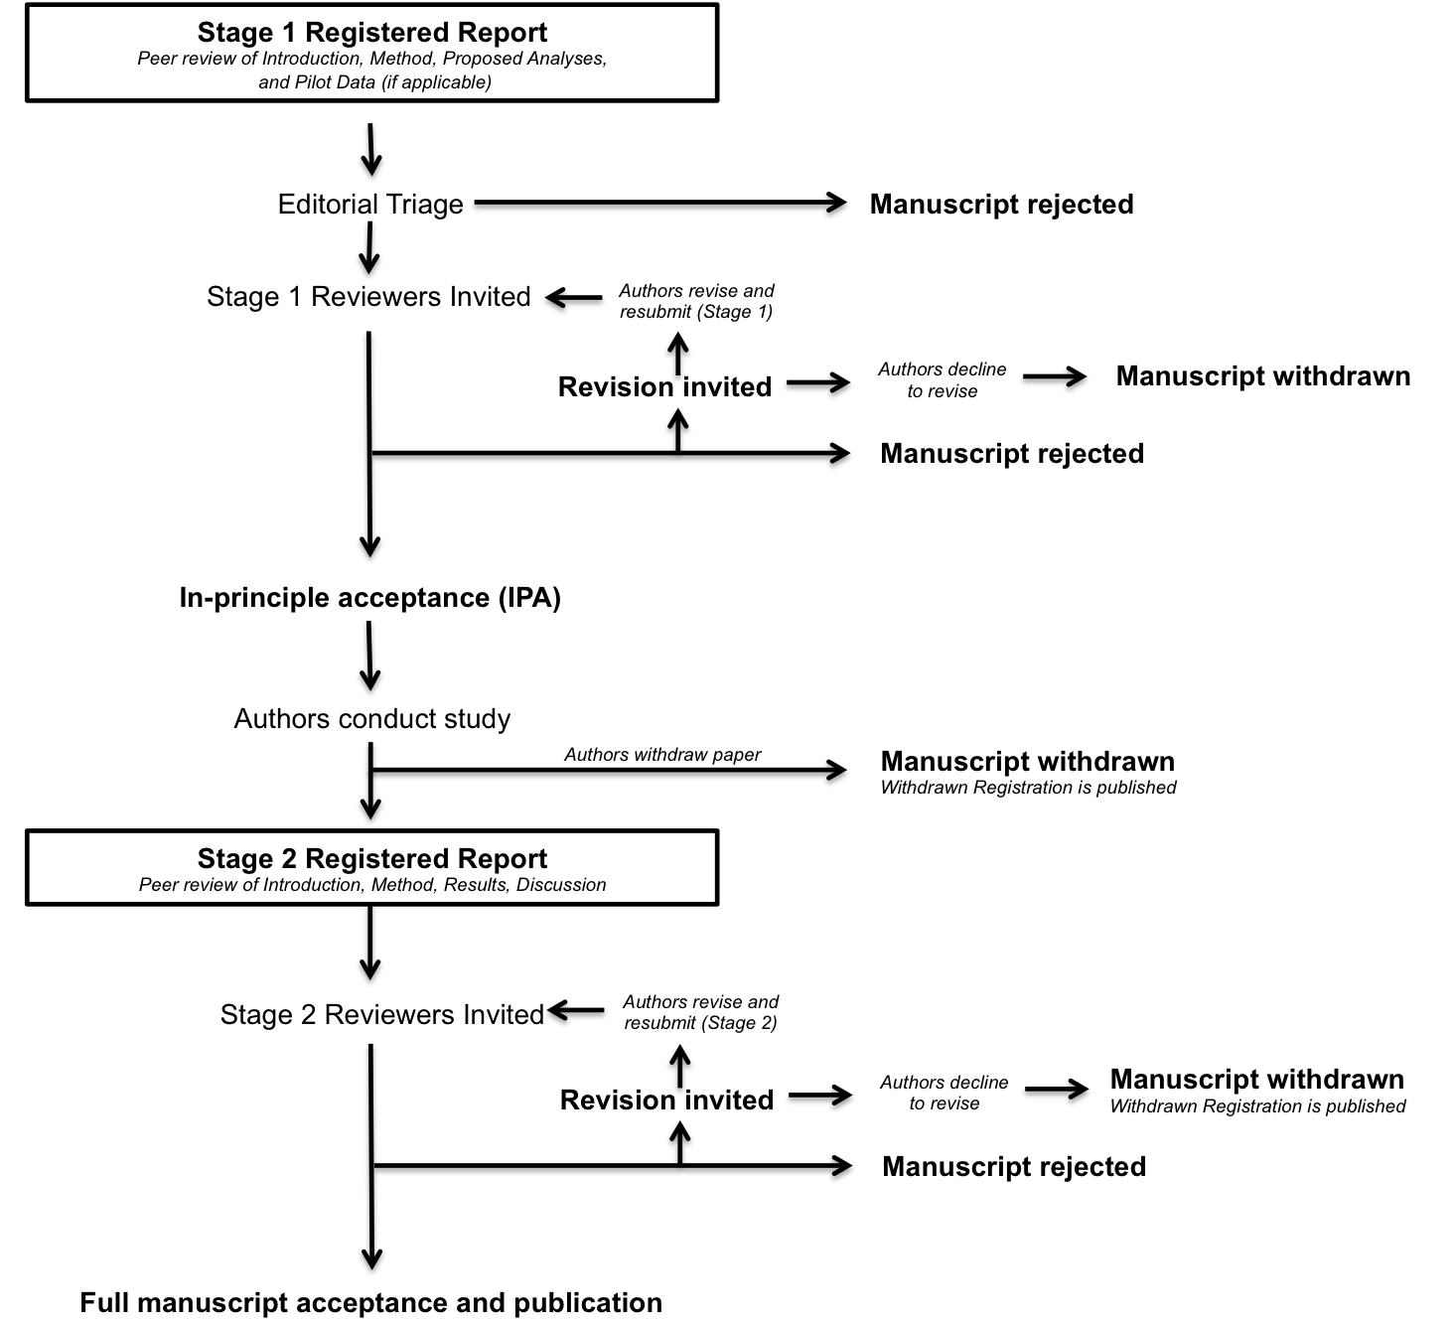

Stage 1: Initial manuscript submission and review

Due to the high volume of submissions, the editors will select only the most scientifically promising manuscripts for in-depth peer review. Stage 1 submissions should include the manuscript (details below) and a brief cover letter. Authors are welcome to submit presubmission enquires for advice on the likely suitability of a study as a Registered Report. However, please note that the editorial board will not agree to send manuscripts for in-depth review until a complete Stage 1 submission has been considered.

The cover letter should include:

- A brief scientific case for consideration. Authors are encouraged to refer to the likely replication value of the research. High-value replication studies are welcome in addition to novel studies.
- A statement confirming that all necessary support (e.g. funding, facilities) and approvals (e.g. ethics) are in place for the proposed research. Note that manuscripts will be generally considered only for studies that are able to commence immediately; however authors with alternative plans are encouraged to contact the journal office for advice.
- An anticipated timeline for completing the study if the initial submission is accepted.
- A statement confirming that the authors agree to share their raw data, any digital study materials, and laboratory log for all published results.
- A statement confirming that if the authors later withdraw their paper, they agree to the Journal publishing a short summary of the pre-registered study under a section Withdrawn Registrations.

Manuscript preparation guidelines – Stage 1

Initial Stage 1 submissions should include the following sections:

- Introduction
  - A review of the relevant literature that motivates the research question and a full description of the experimental aims and hypotheses. Please note that following IPA, the Introduction section cannot be altered (see below).
- Methods
  - Full description of proposed sample characteristics, including criteria for data inclusion and exclusion (e.g. outlier extraction). Procedures for objectively defining exclusion criteria due to technical errors or for any other reasons must be specified, including details of how and under what conditions data would be replaced.
  - A description of experimental procedures in sufficient detail to allow another researcher to repeat the methodology exactly, without requiring further information. These procedures must be adhered to exactly in the subsequent experiments or any Stage 2 manuscript can be rejected.
  - Proposed analysis pipeline, including all preprocessing steps, and a precise description of all planned analyses, including appropriate correction for multiple comparisons. Any covariates or regressors must be stated. Where analysis decisions are contingent on the outcome of prior analyses, these contingencies must be specified and adhered to. Only pre-planned analyses can be reported in the main Results section of Stage 2 submissions. However, unplanned exploratory analyses will be admissible in a separate section of the Results (see below).
  - Studies involving Neyman-Pearson inference must include a statistical power analysis. Estimated effect sizes should be justified with reference to the existing literature. Since publication bias overinflates published estimates of effect size, power analysis must be based on the lowest available or meaningful estimate of the effect size. For frequentist analysis plans, the a priori power must be 0.9 or higher for all proposed hypothesis tests. In the case of highly uncertain effect sizes, a variable sample size and interim data analysis is permissible but with inspection points stated in advance, appropriate Type I error correction for ‘peeking’ employed, and a final stopping rule for data collection outlined.
  - Methods involving Bayesian hypothesis testing are encouraged. For studies involving analyses with Bayes factors, the predictions of the theory must be specified so that a Bayes factor can be calculated. Authors should indicate what distribution will be used to represent the predictions of the theory and how its parameters will be specified. For example, will you use a uniform up to some specified maximum, or a normal/half-normal to represent a likely effect size, or a JZS/Cauchy with a specified scaling constant? For inference by Bayes factors, authors must be able to guarantee data collection until the Bayes factor is at least 6 times in favour of the experimental hypothesis over the null hypothesis (or vice versa). Authors with resource limitations are permitted to specify a maximum feasible sample size at which data collection must cease regardless of the Bayes factor; however to be eligible for advance acceptance this number must be sufficiently large that inconclusive results at this sample size would nevertheless be an important message for the field. For further advice on Bayes factors or Bayesian sampling methods, prospective authors are encouraged to read this key article by Schönbrodt and Wagenmakers and are invited to contact the journal’s Editor-in-Chief.
  - Full descriptions must be provided of any outcome-neutral criteria that must be met for successful testing of the stated hypotheses. Such quality checks might include the absence of floor or ceiling effects in data distributions, positive controls, or other quality checks that are orthogonal to the experimental hypotheses.
  - Timeline for completion of the study and proposed resubmission date if Stage 1 review is successful. Extensions to this deadline can be negotiated with the action editor.
  - Any description of prospective methods or analysis plans should be written in future tense.
- Pilot Data
  - Optional. Can be included to establish proof of concept, effect size estimations, or feasibility of proposed methods. Any pilot experiments will be published with the final version of the manuscript and will be clearly distinguished from data obtained for the pre-registered experiment(s).
- Secondary Registrations
  - The journal welcomes submissions proposing secondary analyses of existing data sets, provided authors can supply sufficient evidence (e.g. letter from independent gatekeeper) to confirm that they have had no prior access to the data in question.

Stage 1 submissions that are judged by the editorial board to be of sufficient quality and scientific importance will be sent for in-depth peer review. In considering papers at the registration stage, reviewers will be asked to assess:

- The importance of the research question(s).
- The logic, rationale, and plausibility of the proposed hypotheses.
- The soundness and feasibility of the methodology and analysis pipeline (including statistical power analysis where appropriate).
- Whether the clarity and degree of methodological detail is sufficient to exactly replicate the proposed experimental procedures and analysis pipeline.
- Whether the authors have pre-specified sufficient outcome-neutral tests for ensuring that the results obtained are able to test the stated hypotheses, including positive controls and quality checks.

Following Stage 1 peer review, manuscripts will be rejected outright, offered the opportunity to revise, or accepted. Proposals that exceed the highest standards of importance and scientific rigour will be issued an in principle acceptance (IPA), indicating that the article will be published pending compleition of the approved methods and analytic procedures, passing of all pre-specified quality checks, and a defensible interpretation of the results. Stage 1 protocols are not published following IPA. Instead they are held in reserve by the journal and integrated into a single completed article following approval of the final Stage 2 manuscript.

Authors are reminded that any deviation from the stated experimental procedures, regardless of how minor it may seem to the authors, could lead to rejection of the manuscript at Stage 2. In cases where the pre-registered protocol is altered after IPA due to unforeseen circumstances (e.g. change of equipment or unanticipated technical error), the authors must consult the editorial board immediately for advice, and prior to the completion of data collection. Minor changes to the protocol may be permitted according to editorial discretion. In such cases, IPA would be preserved and the deviation reported in the Stage 2 submission. If the authors wish to alter the experimental procedures more substantially following IPA but still wish to publish their article as a Registered Report then the manuscript must be withdrawn and resubmitted as a new Stage 1 submission. Note that registered analyses must be undertaken, but additional unregistered analyses can also be included in a final manuscript (see below).

Stage 2: Full manuscript review

Once the study is complete, authors prepare and resubmit their manuscript for full review, with the following additions:

- Submission of raw data and laboratory log
  - Raw data and any digital experimental materials (e.g. stimuli etc.) must be made freely available in a public repository. Data files should be appropriately time stamped to show that data was collected after IPA and not before. Other than pre-registered and approved pilot data, no data acquired prior to the date of IPA is admissible in the Stage 2 submission. Raw data must be accompanied by guidance notes, where required, to assist other scientists in replicating the analysis pipeline. Authors are also expected to upload any relevant analysis scripts and other experimental materials that would assist in replication (e.g. stimuli & presentation code).
  - Any supplementary figures, tables, or other text (such as supplementary methods) can either be included as standard supplementary information that accompanies the paper, or they can be archived together with the data. Please note that the raw data itself should be archived (see above) rather than submitted to the journal as supplementary material.
  - The authors must collectively certify in the resubmission Cover Letter that all non-pilot data was collected after the date of IPA. A basic laboratory log must also be provided outlining the range of dates during which data collection took place. This log should be uploaded to the same public archive as the data, with a link provided to the log in the resubmission Cover Letter.
- Background, Rationale and Methods
  - Apart from minor stylistic revisions, the Introduction cannot be altered from the approved Stage 1 submission, and the stated hypotheses cannot be amended or appended. At Stage 2, any description of the rationale or proposed methodology that was written in future tense within the Stage 1 manuscript should be changed to past tense. Any textual changes to the Introduction or Methods (e.g. correction of typographic errors) must be clearly marked in the Stage 2 submission. Any relevant literature that appeared following the date of IPA should be covered in the Discussion.
- Results & Discussion
  - The outcome of all registered analyses must be reported in the manuscript, except in rare instances where a registered and approved analysis is subsequently shown to be logically flawed or unfounded. In such cases, the authors, reviewers, and editor must agree that a collective error of judgment was made and that the analysis is inappropriate. In such cases the analysis would still be mentioned in the Methods but omitted with justification from the Results.
  - It is reasonable that authors may wish to include additional analyses that were not included in the registered submission. For instance, a new analytic approach might become available between IPA and Stage 2 review, or a particularly interesting and unexpected finding may emerge. Such analyses are admissible but must be clearly justified in the text, appropriately caveated, and reported in a separate section of the Results titled “Exploratory analyses”. Authors should be careful not to base their conclusions entirely on the outcome of statistically significant post hoc analyses.
  - Authors reporting null hypothesis significance tests are required to report exact p values and effect sizes for all inferential analyses.

The resubmission will most likely be considered by the same reviewers as in Stage 1, but could also be assessed by new reviewers. In considering papers at Stage 2, reviewers will be asked to decide:

- Whether the data are able to test the authors’ proposed hypotheses by satisfying the approved outcome-neutral conditions (such as quality checks, positive controls)
- Whether the Introduction, rationale and stated hypotheses are the same as the approved Stage 1 submission (required)
- Whether the authors adhered precisely to the registered experimental procedures
- Whether any unregistered post hoc analyses added by the authors are justified, methodologically sound, and informative
- Whether the authors’ conclusions are justified given the data

Reviewers are informed that editorial decisions will not be based on the perceived importance, novelty or conclusiveness of the results. Thus while reviewers are free to enter such comments on the record, they will not influence editorial decisions. Reviewers at Stage 2 may suggest that authors report additional post hoc tests on their data; however authors are not obliged to do so unless such tests are necessary to satisfy one or more of the Stage 2 review criteria.

Manuscript withdrawal and Withdrawn Registrations
It is possible that authors with IPA may wish to withdraw their manuscript following or during data collection. Possible reasons could include major technical error, an inability to complete the study due to other unforeseen circumstances, or the desire to submit the results to a different journal. In all such cases, manuscripts can of course be withdrawn at the authors’ discretion. However, the journal will publicly record each case in a section called Withdrawn Registrations. This section will include the authors, proposed title, the abstract from the approved Stage 1 submission, and brief reason(s) for the failure to complete the study. Partial withdrawals are not possible; i.e. authors cannot publish part of a registered study by selectively withdrawing one of the planned experiments. Such cases must lead to withdrawal of the entire paper. Studies that are not completed by the agreed Stage 2 submission deadline (which can be extended in negotiation with the editorial office) will be considered withdrawn and will be subject to a Withdrawn Registration.

Incremental Registrations
Authors may add experiments to approved submissions. In such cases the approved Stage 2 manuscript will be accepted for publication, and authors can propose additional experiments for Stage 1 consideration. Where these experiments extend the approved submission (as opposed to being part of new submissions), the editorial team will seek to fast-track the review process. This option may be particularly appropriate where an initial experiment reveals a major serendipitous finding that warrants follow-up within the same paper. In cases where an incremented submission is rejected (at either Stage 1 or 2), authors will retain the option of publishing the most recently approved version of the manuscript. For further advice on specific scenarios for incremental registration, authors are invited to contact the editorial office psyspo@elsevier.com.

